Experiment 4
Verification of System Properties

Objective 1: Linearity and Time Invariance
To verify the linearity and time-invariance properties of continuous-time and discrete-time systems.
CODE :
% Experiment 11: Linearity and Time Invariance
clc; clear; close all;
t = -1:0.001:1;
x1 = sin(2*pi*5*t);
x2 = cos(2*pi*5*t);
a = 2;
b = 3;
t0 = 0.2;
T = @(x) 2*x;
lhs = T(a*x1+b*x2);
rhs = a*T(x1)+b*T(x2);
linError = max(abs(lhs-rhs));
xDelay = sin(2*pi*5*(t-t0));
lhsTI = T(xDelay);
rhsTI = T(x1);
rhsTIshift = interp1(t,rhsTI,t-t0,'linear',0);
tiError = max(abs(lhsTI-rhsTIshift));
figure;
subplot(2,1,1);
plot(t,lhs-rhs);
grid on;
title('Linearity Error');

subplot(2,1,2);
plot(t,lhsTI-rhsTIshift);
grid on;
title('Time-Invariance Error');
fprintf('Linearity error = %g\n',linError);
fprintf('Time-invariance error = %g\n',tiError);

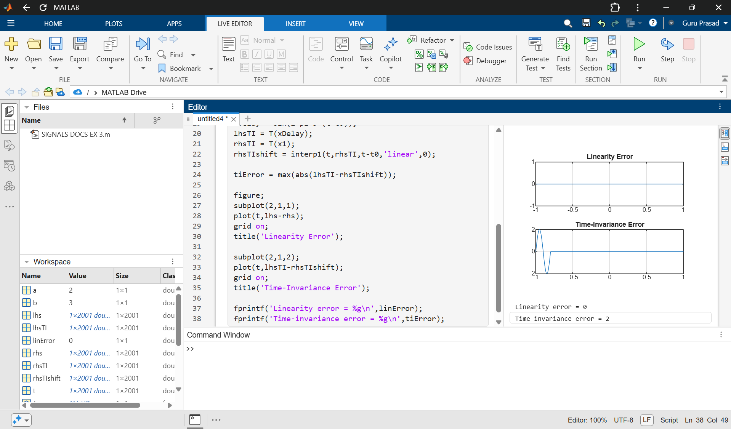

Objective 2: Causality and Non-Causality
Aim: To classify systems as causal or non-causal based on their input-output relationships.
CODE :
% Experiment 12: Causality and Non-Causality
clc; clear; close all;
n = -10:10;
x = sin(0.2*pi*n);
yC = x + [0 x(1:end-1)];
yNC = x + [x(2:end) 0];
figure;
subplot(3,1,1);
stem(n,x,'filled');
grid on;
title('Input x[n]');
subplot(3,1,2);
stem(n,yC,'filled');
grid on;
title('Causal System y[n]=x[n]+x[n-1]');
subplot(3,1,3);
stem(n,yNC,'filled');
grid on;
title('Non-Causal System y[n]=x[n]+x[n+1]');

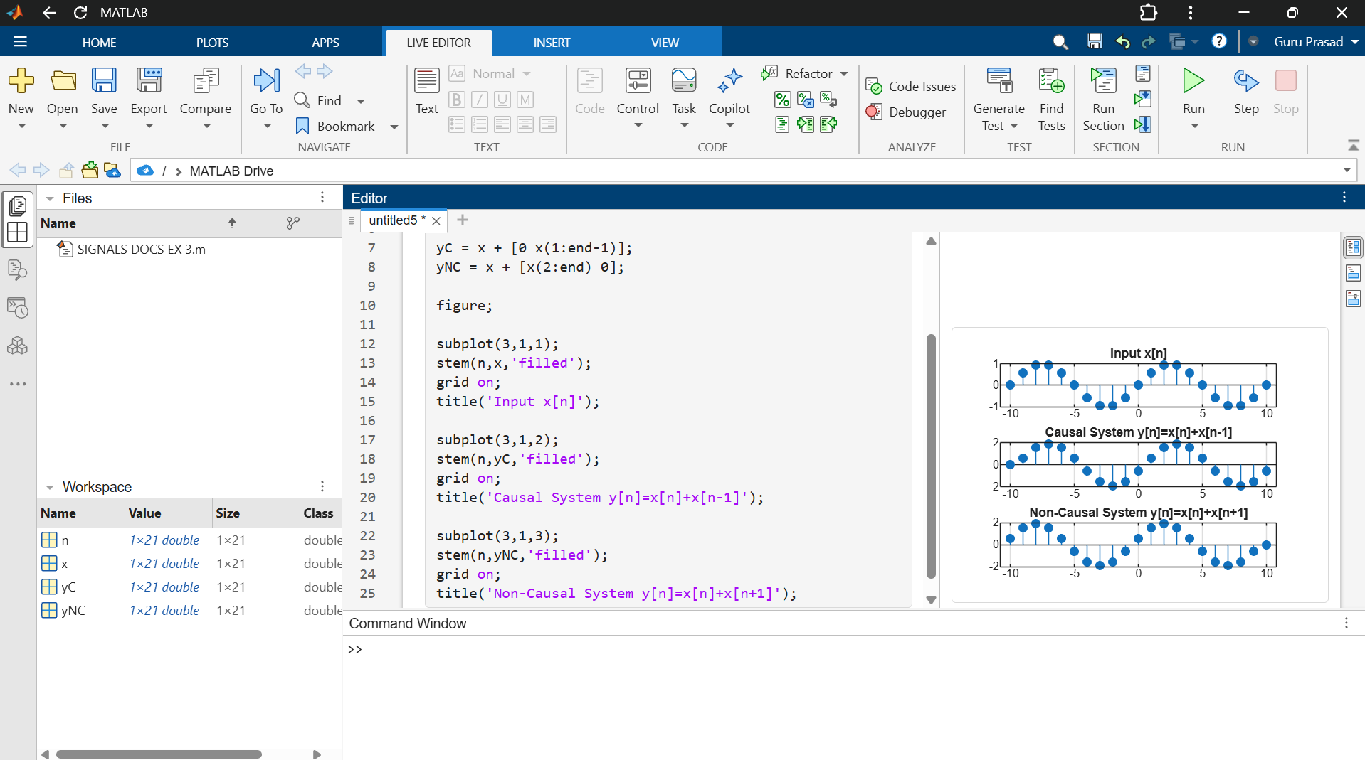

Objective 3: Memoryless and Dynamic Systems
Aim: To classify systems based on whether their outputs depend only on the present input or also on other input values.
CODE :
% Experiment 13: Memoryless and Dynamic Systems
clc; clear; close all;
n = -10:10;
x = sin(0.2*pi*n);
yMemoryless = 3*x;
yDynamic = x + [0 x(1:end-1)];
figure;
subplot(3,1,1);
stem(n,x,'filled');
grid on;
title('Input x[n]');

subplot(3,1,2);
stem(n,yMemoryless,'filled');
grid on;
title('Memoryless: y[n]=3x[n]');
subplot(3,1,3);
stem(n,yDynamic,'filled');
grid on;
title('Dynamic: y[n]=x[n]+x[n-1]');

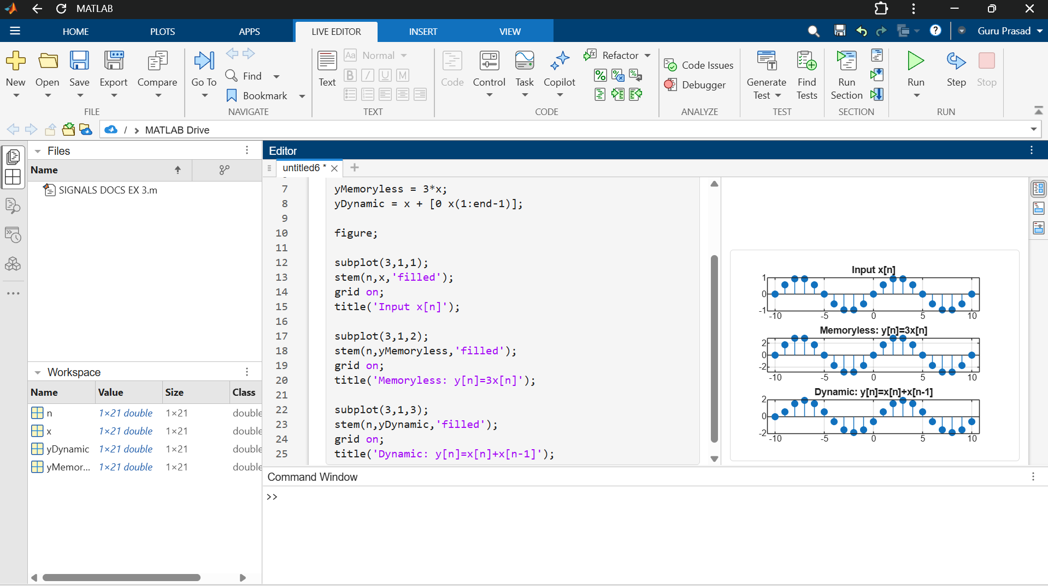

Objective 4: BIBO Stability
Aim: To verify the stability of systems and classify them as stable or unstable.
CODE :

% Experiment 14: BIBO Stability
clc; clear; close all;
t = 0:0.001:5;
x = sin(2*pi*5*t);
yStable = 0.5*x;
yUnstable = exp(t).*x;
figure;
subplot(3,1,1);
plot(t,x);
grid on;
title('Bounded Input x(t)');
subplot(3,1,2);
plot(t,yStable);
grid on;
title('Stable Output y(t)=0.5x(t)');
subplot(3,1,3);
plot(t,yUnstable);
grid on;
title('Unstable Output y(t)=e^t x(t)');
fprintf('Maximum stable output = %g\n',max(abs(yStable)));
fprintf('Maximum unstable output over simulation = %g\n',max(abs(yUnstable)));

